Communication |  | Commande | Depuis le poste | Rés commande
PC0 | PC1 | ping 192.168.0.5 | PC0 | Réussite
PC0 | PC2 | ping 192.168.0.9 | PC0 | Réussite
PC0 | PC3 | ping 192.168.1.2 | PC0 | Failed
PC1 | PC2 | ping 192.168.0.9 | PC1 | Réussite
PC1 | PC3 | ping 192.168.1.2 | PC1 | Failed
PC2 | PC3 | ping 192.168.1.2 | PC2 | Failed

4) La communication vers PC3 est impossible car ce n’est pas le même sous réseau

5) On peut changer l’adresse IP de PC3 en 192.168.0.4

6) a)
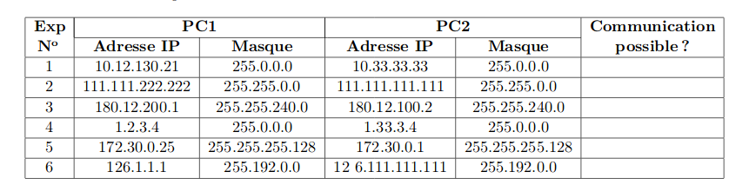

OK
OK
fail
ok
ok
fail

b)
Experimentation n°1
PC1
 | 10 |  |  |  |  |  |  |  | 12 |  |  |  |  |  |  |  | 130 |  |  |  |  |  |  |  | 21
 | 0 | 0 | 0 | 0 | 1 | 0 | 1 | 0 | 0 | 0 | 0 | 0 | 1 | 1 | 0 | 0 | 1 | 0 | 0 | 0 | 0 | 0 | 1 | 0 | 0 | 0 | 0 | 1 | 0 | 1 | 0 | 1
 | 255 |  |  |  |  |  |  |  | 0 |  |  |  |  |  |  |  | 0 |  |  |  |  |  |  |  | 0
 | 1 | 1 | 1 | 1 | 1 | 1 | 1 | 1 | 0 | 0 | 0 | 0 | 0 | 0 | 0 | 0 | 0 | 0 | 0 | 0 | 0 | 0 | 0 | 0 | 0 | 0 | 0 | 0 | 0 | 0 | 0 | 0
 | 10 |  |  |  |  |  |  |  | 0 |  |  |  |  |  |  |  | 0 |  |  |  |  |  |  |  | 0
 | 0 | 0 | 0 | 0 | 1 | 0 | 1 | 0 | 0 | 0 | 0 | 0 | 0 | 0 | 0 | 0 | 0 | 0 | 0 | 0 | 0 | 0 | 0 | 0 | 0 | 0 | 0 | 0 | 0 | 0 | 0 | 0
PC2
 | 10 |  |  |  |  |  |  |  | 33 |  |  |  |  |  |  |  | 33 |  |  |  |  |  |  |  | 33
 | 0 | 0 | 0 | 0 | 1 | 0 | 1 | 0 | 0 | 0 | 1 | 0 | 0 | 0 | 0 | 1 | 0 | 0 | 1 | 0 | 0 | 0 | 0 | 1 | 0 | 0 | 1 | 0 | 0 | 0 | 0 | 1
 | 255 |  |  |  |  |  |  |  | 0 |  |  |  |  |  |  |  | 0 |  |  |  |  |  |  |  | 0
 | 1 | 1 | 1 | 1 | 1 | 1 | 1 | 1 | 0 | 0 | 0 | 0 | 0 | 0 | 0 | 0 | 0 | 0 | 0 | 0 | 0 | 0 | 0 | 0 | 0 | 0 | 0 | 0 | 0 | 0 | 0 | 0
 | 10 |  |  |  |  |  |  |  | 0 |  |  |  |  |  |  |  | 0 |  |  |  |  |  |  |  | 0
 | 0 | 0 | 0 | 0 | 1 | 0 | 1 | 0 | 0 | 0 | 0 | 0 | 0 | 0 | 0 | 0 | 0 | 0 | 0 | 0 | 0 | 0 | 0 | 0 | 0 | 0 | 0 | 0 | 0 | 0 | 0 | 0
OUI

Experimentation n°1
PC1
 | 180 |  |  |  |  |  |  |  | 12 |  |  |  |  |  |  |  | 200 |  |  |  |  |  |  |  | 1
 | 1 | 0 | 1 | 1 | 0 | 1 | 0 | 0 | 0 | 0 | 0 | 0 | 1 | 1 | 0 | 0 | 1 | 1 | 0 | 0 | 1 | 0 | 0 | 0 | 0 | 0 | 0 | 0 | 0 | 0 | 0 | 1
 | 255 |  |  |  |  |  |  |  | 255 |  |  |  |  |  |  |  | 240 |  |  |  |  |  |  |  | 0
 | 1 | 1 | 1 | 1 | 1 | 1 | 1 | 1 | 1 | 1 | 1 | 1 | 1 | 1 | 1 | 1 | 1 | 1 | 1 | 1 | 0 | 0 | 0 | 0 | 0 | 0 | 0 | 0 | 0 | 0 | 0 | 0
 | 180 |  |  |  |  |  |  |  | 12 |  |  |  |  |  |  |  | 192 |  |  |  |  |  |  |  | 0
 | 1 | 0 | 1 | 1 | 0 | 1 | 0 | 0 | 0 | 0 | 0 | 0 | 1 | 1 | 0 | 0 | 1 | 1 | 0 | 0 | 0 | 0 | 0 | 0 | 0 | 0 | 0 | 0 | 0 | 0 | 0 | 0
PC2
 | 180 |  |  |  |  |  |  |  | 12 |  |  |  |  |  |  |  | 100 |  |  |  |  |  |  |  | 2
 | 1 | 0 | 1 | 1 | 0 | 1 | 0 | 0 | 0 | 0 | 0 | 0 | 1 | 1 | 0 | 0 | 0 | 1 | 1 | 0 | 0 | 1 | 0 | 0 | 0 | 0 | 0 | 0 | 0 | 0 | 1 | 0
 | 255 |  |  |  |  |  |  |  | 255 |  |  |  |  |  |  |  | 240 |  |  |  |  |  |  |  | 0
 | 1 | 1 | 1 | 1 | 1 | 1 | 1 | 1 | 1 | 1 | 1 | 1 | 1 | 1 | 1 | 1 | 1 | 1 | 1 | 1 | 0 | 0 | 0 | 0 | 0 | 0 | 0 | 0 | 0 | 0 | 0 | 0
 | 180 |  |  |  |  |  |  |  | 12 |  |  |  |  |  |  |  | 96 |  |  |  |  |  |  |  | 0
 | 1 | 0 | 1 | 1 | 0 | 1 | 0 | 0 | 0 | 0 | 0 | 0 | 1 | 1 | 0 | 0 | 0 | 1 | 1 | 0 | 0 | 0 | 0 | 0 | 0 | 0 | 0 | 0 | 0 | 0 | 0 | 0
NON

c) il faut que les deux pc aient la même adresse réseau

Exercice 3)
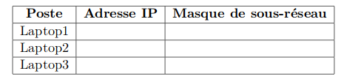
4) switch choisit ou l’envoyer et hub envoit a tot le monde

Exercice 4)
10.1.1.1255.0.0.0

10.2.2.2255.0.0.0
10.3.3.3255.0.0.0

